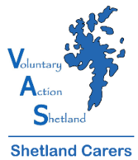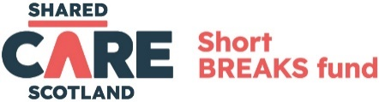
2024/25 CRITERIA FOR SHORT BREAK GRANTS
- The applicant is currently caring for someone of any age.
- The applicant is doing a significant amount of caring, which is having an impact on their own health and wellbeing.
- The break will benefit the carer’s wellbeing.
- Applicants can only receive ONE grant per year. If there is more than one carer in the family, only one application can be received per household, unless there is more than one cared for person in the family. If there is more than one cared for person, more than one carer can apply from the same household if the applications relate to different cared for persons.
- Young carers can apply in addition to another carer from the same household, even where there is only one cared for person.
- Details of the intended break to be provided, along with a costing and a brief description of how the break will benefit you.
- Applicant has not received a short break grant from another source eg Alzheimer’s Scotland
- Other forms of support have been taken into account eg SCAS, local authority respite, care at home
- If the fund is oversubscribed, priority will be given to carers who have not previously applied to the fund in the last grant period.
On receipt of your short break grant application, Shetland Carers Support Workers will talk with you about your Health and Wellbeing and measure your scores in certain areas. These will also be taken into consideration by the panel when the applications are being assessed.
Priority will be given to:-
- Carers who do not have other family members to support them
- Carers who are experiencing social isolation
- Carers who have health and wellbeing conditions themselves
Notes about application process
- Grants will be allocated seven times per year at short break panel meetings. Our meeting dates for this grant year are 17th June 2024, 5th August 2024, 16th September 2024, 28th October 2024, 9th December 2024, 20th January 2025 and 3rd March 2025. Applications that are time critical can be assessed at the panel’s discretion in between meetings. Applicants will be advised within one week of the meeting the outcome of their application.
- Any grant awarded will reflect a contribution towards the break, subject to a maximum amount of £250.
- Carers may be invited to meet with Shetland Carers Support Workers to discuss their application if further information is required.

