Our Community Groups are there to be enjoyed by anyone living with dementia or experiencing difficulties with their memory, including their families and friends. All are welcome; people who can attend independently and/or, for those unable to do so should come with a companion who can provide any support for them.
We are unable to transport for these groups and therefore it is your responsibility to get to and from this community activity, safely. Please speak to us, so we can support you to explore other transport options.
We are also here for you with a warm drink, food and company, please see below for more details. If you are unsure, or have questions about any of the groups, or have an idea for a new group, please let us know. Contact:
Community Activities Organiser: Alanda Anderson 01595 720344/07760177049
Dementia Advisor: Jan Brown 01595 720343/07795256424
In Person Group
Thursday 4th  January | TLC talks – Carer Group  66 Burgh Road, Lerwick | 10.30 – 12.00
Wednesday 10th January | Dementia Advisor Drop-in  66 Burgh Road, Lerwick | 13.00 – 15.00
Thursday 11th January | TLC talks – Carer Group  66 Burgh Road, Lerwick | 10.30 – 12.00
Friday 12th January | You, Me and Grief (1/6)  6wk course with Dementia Advisor  To guide you through the grieving  process  groups up to 8 people please pre book  DRC 66 Burgh Road, Lerwick | 10.30 – 12.00
Friday 12th January | Shanty Sing Along with Soup!  Staney Hill Hall, Ladies Drive, Lerwick | 13.30 – 15.30
Wednesday 17th January | Dementia Advisor Drop-in  66 Burgh Road, Lerwick | 10.30 – 12.00
Wednesday 17th January | Gadderie group  Shetland Museum visit with tea/coffee  Hays Dock, Lerwick | 14.00 – 15.30
Thursday 18th January | TLC talks – Carer Group  66 Burgh Road, Lerwick | 10.30 - 12.00
Friday 19th January | You, Me and Grief (2/6)  with Dementia Advisor to guide you through the grieving process  please pre book  DRC 66 Burgh Road, Lerwick | 10.30 – 12.00
\Thursday 25th January | TLC talks – Carer Group  66 Burgh Road, Lerwick | 10.30 - 12.00
Friday 26th January | You, Me and Grief (3/6)  6wk course with Dementia Advisor  please pre book  DRC 66 Burgh Road Lerwick | 10.30 – 12.00
Friday 26th January | Shanty Sing Along with Soup!  Staney Hill Hall, Ladies Drive, Lerwick | 13.30 – 15.30
Wednesday 31st January | Dementia Advisor Drop-in  66 Burgh Road, Lerwick | 10.30 – 12.00
Wednesday 31st January | Gadderie group  Shetland Museum visit with tea/coffee  Hays Dock, Lerwick | 14.00 – 15.30
Living Well Hub | Do you have a question about services in Shetland and how you can access them? Drop in for a cuppa and a chat with Rita and Theresa at: Scalloway Youth & Community Centre on a Wednesday morning from 9.00 – 13.00 DA visit 24th January 10.00 – 12.00  Speldiburn Café, Bressay School on a Wednesday afternoon from 14.00 – 16.00  Brae Youth Centre on a Monday morning from 10.00 – 14.00 or on a Friday from 10.00 – 16.00  Call 01595 744120  livingwellhub@shetland.gov.uk
 | Dementia Inclusive Activities and Events in Shetland
The Well | Worship Experience for Later Life  Held the first Wednesday of each month at  Lerwick Methodist Church, Hillhead, Lerwick | 14.00 - 15.00
Cuppa at Quoys | Enjoy some cake and a cuppa every Tuesday morning at  Lerwick Baptist Church, Quoys, Lerwick | 10.00 - 12.00
Paths for All Health Walks | Dementia Friendly Walk Leaders organise weekly walks in different locations across Shetland.  For more information about your local group contact  Krissi Sandison: 01595 807494 / 07824477225
Yarners Group | Thursday afternoon reminiscence sessions (Cuppa & Chat)  Hoswick Visitor Centre, Sandwick  * Please check details with the centre on 01950 431406 before you set off. | 14.30 - 16.00

For further information about any of our groups please contact us:
Dementia Advisor: Jan Brown 01595 720343/07795256424

Community Activities Organiser Alanda Anderson 01595 720344/07760177049

Localities Lead: Catriona MacRitchie 01851 307467/07824561305
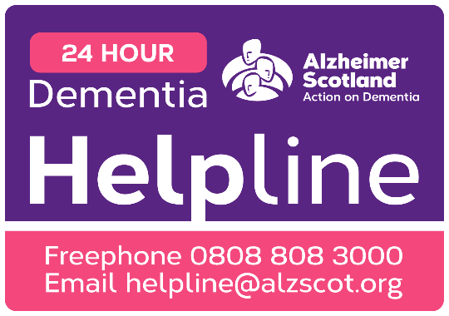
Our support and activities are only possible thanks to the donations we gratefully receive. There are many ways to support our groups, please speak to any member of staff detailed above for more details. To make a donation, please consider donating to our local Just Giving page https://www.justgiving.com/fundraising/

Our National Dementia Advisor Service is now available:
Monday – Friday 9am – 5pm
0300 373 5774

